**Project Design Phase-II**

**Data Flow Diagram & User Stories**

|  |  |
| --- | --- |
| Date | 14 October 2022 |
| Team ID | PNT2022TMID48082 |
| Project Name | Project - Smart Waste Management System For Metropolitan Cities |
| Maximum Marks | 4 Marks |

**Data Flow Diagrams:**

A Data Flow Diagram (DFD) is a traditional visual representation of the information flows within a system. A neat and clear DFD can depict the right amount of the system requirement graphically. It shows how data enters and leaves the system, what changes the information, and where data is stored.

Example: Data Flow Diagram For Smart Cities

**Example: [(Simplified)](https://developer.ibm.com/patterns/visualize-unstructured-text/)**

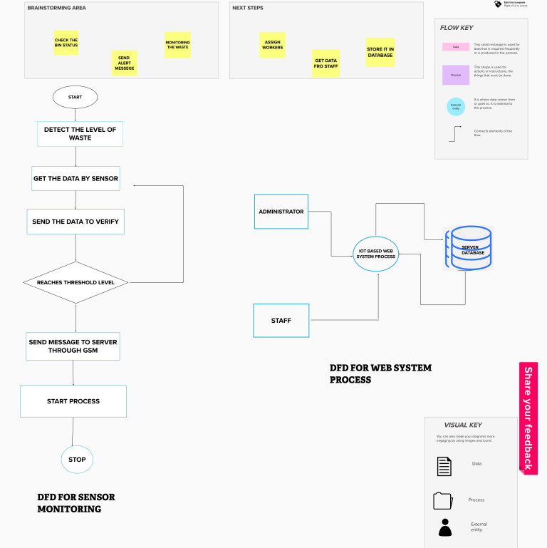

**](https://developer.ibm.com/patterns/visualize-unstructured-text/)**

**User Stories**

Use the below template to list all the user stories for the product.

|  |  |  |  |  |  |  |
| --- | --- | --- | --- | --- | --- | --- |
| **User Type** | **Functional**  **Requirement (Epic)** | **User Story Number** | **User Story / Task** | **Acceptance criteria** | **Priority** | **Release** |
| Admin (who manage web server) | Web server login | USN-1 | As a admin, I have my user name and password for every worker and co-workers to manage them. | I can manage web account and direct workers. | High | Sprint-1 |
| Co-admin | Login | USN-2 | As a co-admin, I’ll manage other monitoring activities like garbage level monitoring, location accuracy, garbage separation and removal of waste within a scheduled time. | I can monitor garbage bins activities. | High | Sprint-2 |
| Customer (Web user) | User | USN-3 | Here comes the customer, he/she will have access to mobile apps or login web pages to view progress of bins and to report if any query found. | He/ she has the right to make a query if any. | High | Sprint-3 |
| Customer Care Executive | Worker | USN-4 | The customer care executive, will try to rectify the queries from customers by contacting co- admin. If case of any critical/ emergency situation query can be conveyed to higher  authority. | I can attend calls and respond people by rectifying the problem. | High | Sprint-4 |
| Truck driver | Worker | USN-5 | Here, truck driver is a worker who has particular assignments that he has to report when and where the garbage has been picked according to the daily schedule. And should update the happenings in the given website  (web page login). | I can update my activities on site when the given task has been completed. | Moderate | Sprint-5 |